Additional instructions for lab one. If you have time, go ahead and start making observations on arthropods, by observing barnacles.

Since jointed appendages are one of the key characteristics of arthropods we are going to focus on how arthropods move and use those appendages not only in locomotion but feeding.

**Please obtain a movie of barnacle feeding (and mating if possible). If specimens are available, photographs of barnacle larvae. While observing barnacles, please note what other critters are attached or living among the barnacles. These often prove more interesting than the barnacles themselves or at least more cooperative in feeding. For example any flake food will do for snails and crabs. For now just compile if there is time, a list for the class.**

**If you find an interesting critter, share your observation with the class.**

**We often cannot keep these colonies going in lab for a number of reasons, wrong temperatures, not enough food provided consistently, etc. One of the most common problems is that even though we try to clean the colony, we miss a snail or crab that through time devours the whole colony, one poor barnacle after another, before being found. Housing and food is provided for the unwanted guest and all in one place.**

Examine the diagram below of a barnacle, a crustacean or type of arthropod. The barnacle feeds with its legs.

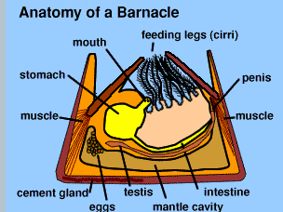

***a. You are to film and describe feeding in a barnacle.***

Obtain a dish of barnacles or if all are in one dish simply gently scoot a barnacle or two into a smaller container. Make sure the smaller container can hold enough water to cover the barnacle. While you are waiting for the animal to adjust to its new surroundings, document any animals that are using the barnacle as habitat. Those students obtaining the dish containing the larger colony should share their observations with the class. In a large colony, you should be able to see most of the major groups of animals we have been discussing in lecture.

(Hint: Patience is the key here to good filming.)

Focus and adjust your lighting using the empty container that will house your barnacle. Place your barnacle under the stereoscope, lights off and wait for it to become adjusted to its new surroundings. If you barnacle does not try to feed after it is set and left alone in its new container for a few minutes, you can try feeding it phytoplankton. Simply use a small pipette to obtain some food to add to your dish containing the barnacle. **Just a tiny amount of food will do, released near some specimens.**

Is there evidence of mating? If so, please film mating in these animals. Reference <https://www.youtube.com/watch?v=lfnkFxg1gMw>

Good filming, biology ok, more about that on guides.

**b. Barnacle larvae. May not be available.** The diagram below shows a Nauplius larva on your left and a Cyprid larva on your right and a Cyprid larva attaching to the substrate to assume the sessile lifestyle of the adult. The Cyprid larva is an older larva that the Nauplius larva.

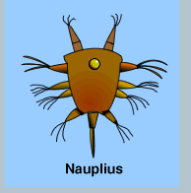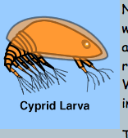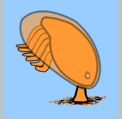

Sometimes larvae will be released during the night by animals stressed by travel. If larvae are produced during the night, they will be visible as small white objects darting around in these dishes. Your teaching assistant will check the dish containing barnacles to see if he sees such larvae. <https://www.youtube.com/watch?v=BKSqQDQ6xk8>

Use a small pipette to obtain some of these if present, place in the smallest dish available, and observe how they move under the highest power of the stereoscope. *Record your observations, obtaining photographs whenever possible.*